

19P0012 AITZAZ TAHIR CH

DATA BASE LAB 08 SIR MUHAMMAD USMAN



**E 8.1 Create a single-column index using attribute park_name in the themepark table.**

create index pname on themepark (park_name);

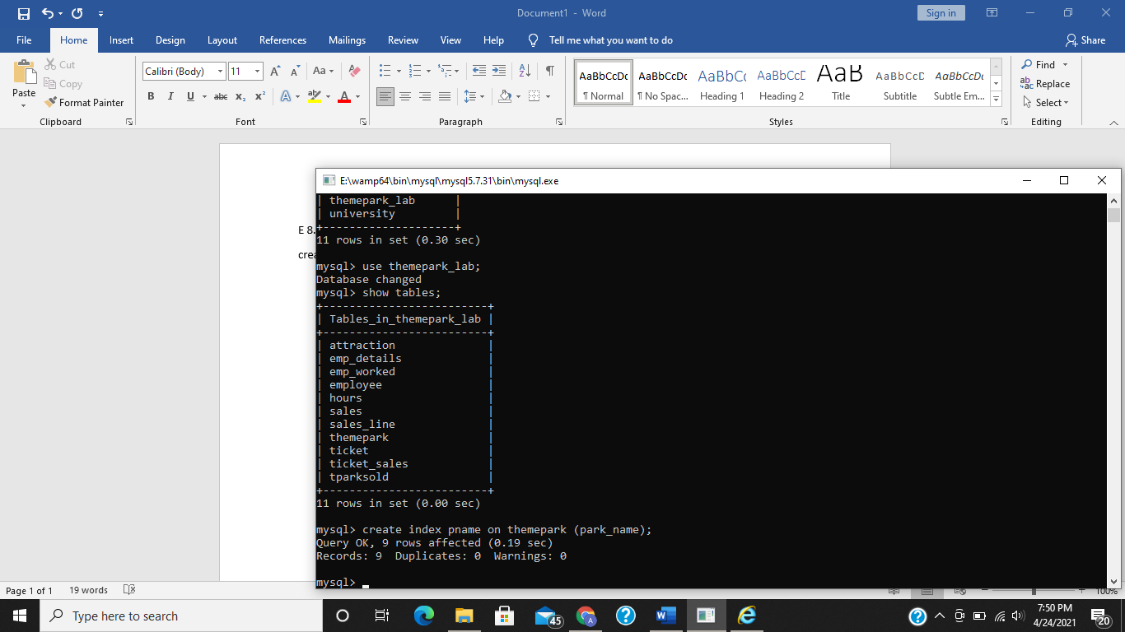

**E 8.2 Create a composite-column index using attributes park_city and park_country.**

create index paddress on themepark (park_city,park_country);

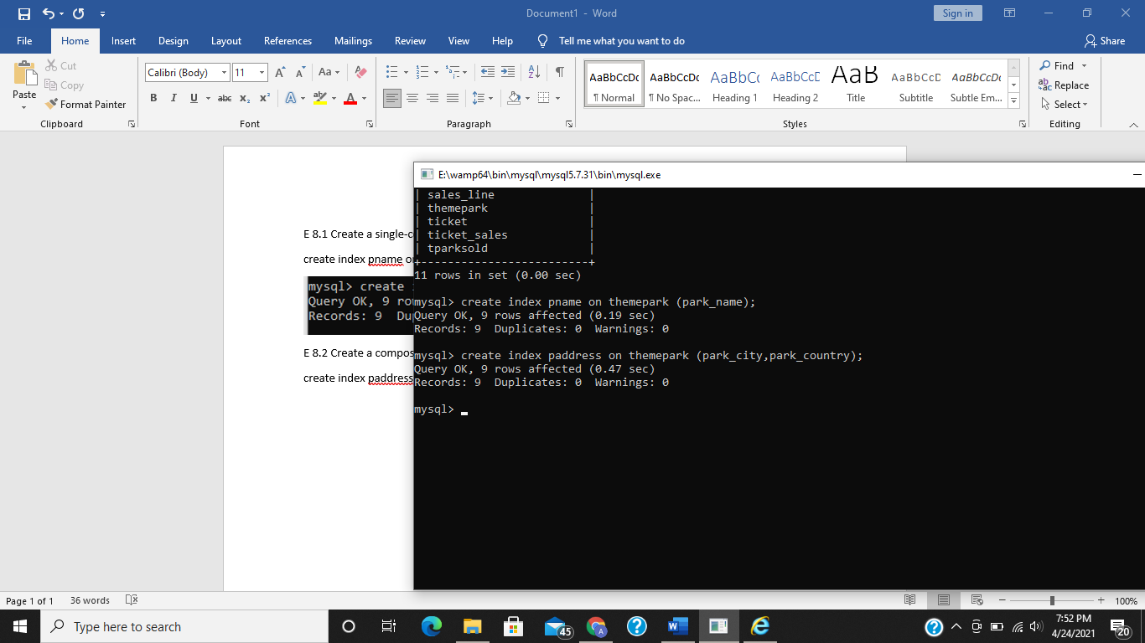

**E 8.3 Display the list of indexes for table themepark.**

show index from themepark;

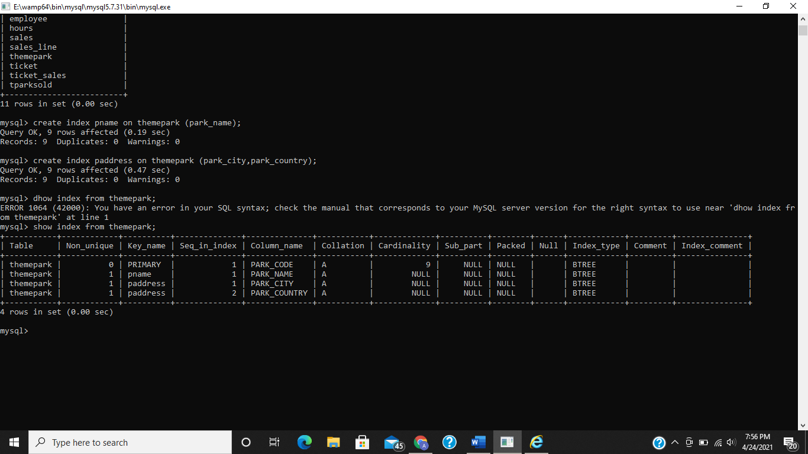

**E 8.4 What is implicit index and unique index?**

**Implicit index:**

Implicit indexes are indexes that are automatically created by the database server (default mode) when an object is created. Indexes are automatically created for primary key constraints and unique constraints.

**Unique index:**

Unique indexes are used not only for performance, but also for data integrity. A unique index does not allow any duplicate values to be inserted into the table.

The basic syntax is as follows.

CREATE UNIQUE INDEX index_name on table_name (column_name);

**E 8.5 Your task is:**

**Create a database named nutec having table named registrations.**

**Make two pages using php and html**

**1. Registration event page**

**This page allow the user to fill the form and on clicking on submit button the record will get**

**inserted into the table registrations you have already defined in database nutec**

**2. Registration record page**

**Select the searching option (roll no, event name, department), then make a field to enter data accordingly to search and show the results accordingly.**

create database nutec;

create table registrations(

-> roll_no numeric(10) primary key,

-> name varchar(20) not null,

-> email varchar(20) not null,

-> department varchar(30) not null,

-> event varchar(20) not null);

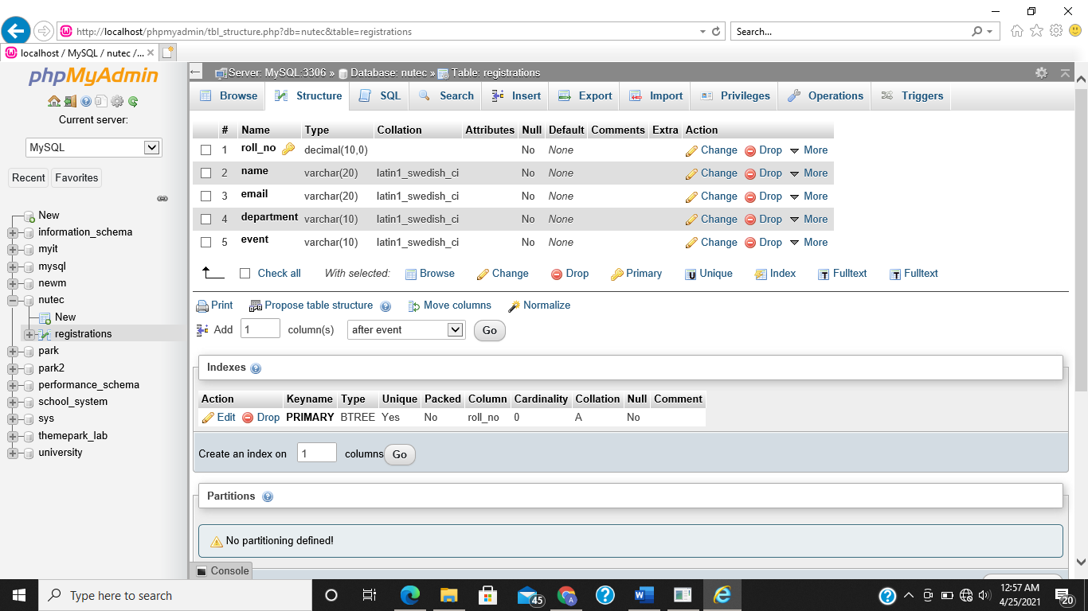

**Registration event page:**

<html>

<head>

<link href="https://cdn.jsdelivr.net/npm/bootstrap@5.0.0-beta3/dist/css/bootstrap.min.css" rel="stylesheet" integrity="sha384-eOJMYsd53ii+scO/bJGFsiCZc+5NDVN2yr8+0RDqr0Ql0h+rP48ckxlpbzKgwra6" crossorigin="anonymous">

<title>Nutec'21 Registration</title>

</head>

<body>

<?php if (isset($_POST['submitted'])){

//this code is executed when the data is submitted

$username = 'root';

$password = '';

try {

$conn = new PDO("mysql:host=localhost;dbname=nutec", $username, $password);

// set the PDO error mode to exception

$conn->setAttribute(PDO::ATTR_ERRMODE, PDO::ERRMODE_EXCEPTION);

echo "Connected successfully";

} catch(PDOException $e) {

echo "Connection failed: " . $e->getMessage();

}

$roll_no = $_POST['roll_no'];

$name = $_POST['name'];

$email = $_POST['email'];

$department = $_POST['department'];

$event = $_POST['event'];

$query_1 = $conn->query('use nutec');

$query_2 = $conn->prepare("INSERT INTO REGISTRATIONS VALUES (?,?,?,?,?)");

$query_2->execute([$roll_no,$name,$email,$department,$event]);

?>

<h3>Congratulations!!! you have been registered</h3>

<p>Go <a href="/8.5.1.php">back</a> to the form</p>

<?php }

else { ?>

<h2>Nutec'21 Event Registration For Fastians</h2>

<form action="8.5.1.php" method="POST">

<div class="mb-3">

<label>Roll No:</label>

<input type="text" name="roll_no">

<label>NAME:</label>

<input type="text" name="name">

<label>Email:</label>

<input type="text" name="email">

<br>

<label>Department:</label>

<select class="form-select" aria-label="Default select example" name="department">

<option value="Computer Science">Computer Science</option>

<option value="Electrical Engineering">Electrical Engineering</option>

<option value="Software Engineering">Software Engineering</option>

</select>

<label>Event:</label>

<select class="form-select" aria-label="Default select example" name="event">

<option value="Welcome Party">Welcome Party</option>

<option value="Bonfire">Bonfire</option>

<option value="Dj Night">Dj NIght</option>

</select>

<input type="hidden" name="submitted" value="1" />

<input class="btn btn-primary" type="submit" value="Submit">

</div>

</form>

<?php } ?>

</body>

</html>

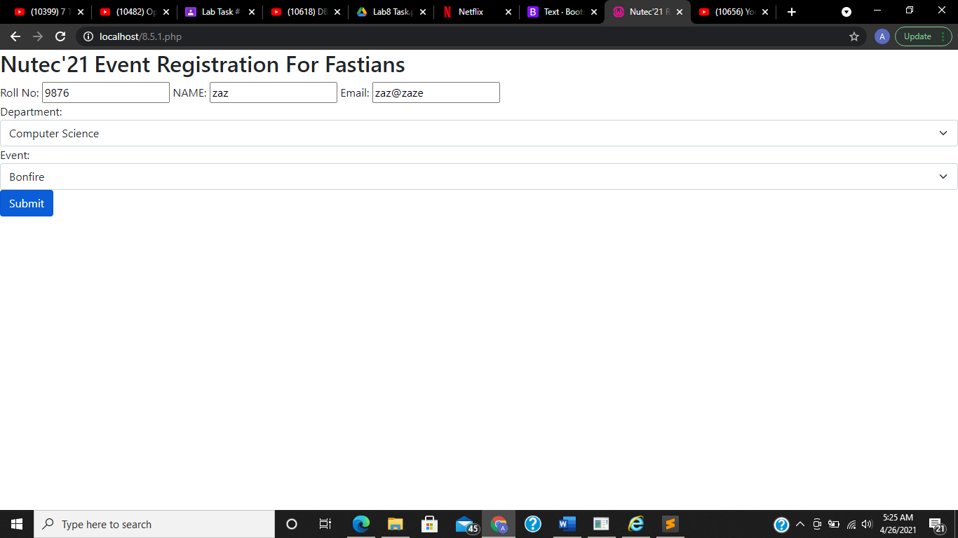

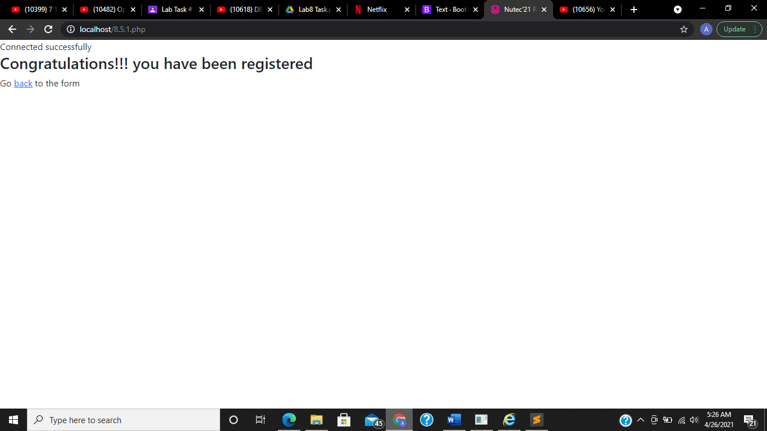

**Registration record page:**

<html>

<head>

<link href="https://cdn.jsdelivr.net/npm/bootstrap@5.0.0-beta3/dist/css/bootstrap.min.css" rel="stylesheet" integrity="sha384-eOJMYsd53ii+scO/bJGFsiCZc+5NDVN2yr8+0RDqr0Ql0h+rP48ckxlpbzKgwra6" crossorigin="anonymous">

<title>Nutec'21 Registration</title>

</head>

<body>

<?php if (isset($_POST['submitted'])){

//this code is executed when the data is submitted

$username = 'root';

$password = '';

try {

$conn = new PDO("mysql:host=localhost;dbname=nutec", $username, $password);

// set the PDO error mode to exception

$conn->setAttribute(PDO::ATTR_ERRMODE, PDO::ERRMODE_EXCEPTION);

echo "Connected successfully";

} catch(PDOException $e) {

echo "Connection failed: " . $e->getMessage();

}

$typ = $_POST['typ'];

$val = $_POST['val'];

$query_1 = $conn->query('use nutec');

if($typ == 'roll_no')

{

$query_2 = $conn->prepare("SELECT * FROM REGISTRATIONS WHERE roll_no = ?");

$query_2->execute([$val]);

}

elseif($typ == 'department')

{

$query_2 = $conn->prepare("SELECT * FROM REGISTRATIONS WHERE department = ?");

$query_2->execute([$val]);

}

elseif($typ == 'event')

{

$query_2 = $conn->prepare("SELECT * FROM REGISTRATIONS WHERE event = ?");

$query_2->execute([$val]);

}

$result_1 = $query_2->fetchall(PDO::FETCH_ASSOC);

//print_r($result_1);

?>

<h2>Output</h2>

<table class="table table-hover">

<thead>

<tr>

<th>Roll No</th>

<th>Name</th>

<th>Email</th>

<th>Department</th>

<th>Event</th>

</tr>

</thead>

<tbody>

<?php

foreach ($result_1 as $key => $value) {

echo'<tr>

<td>'.$value['roll_no'].'</td>

<td>'.$value['name'].'</td>

<td>'.$value['email'].'</td>

<td>'.$value['department'].'</td>

<td>'.$value['event'].'</td>

</tr>';

}

?>

</tbody>

</table>

<p>Go <a href="/8.5.2.php">back</a> to the form</p>

<?php }

else { ?>

<h2>Nutec'21 Event Registration For Fastians</h2>

<form action="8.5.2.php" method="POST">

<div class="mb-3">

<label>Search By:</label>

<select class="form-select" aria-label="Default select example" name="typ">

<option value="roll_no">Roll No</option>

<option value="department">Department</option>

<option value="event">Event</option>

</select>

<label>Enter Data:</label>

<input type="text" name="val">

<input type="hidden" name="submitted" value="1" />

<br>

<input class="btn btn-primary" type="submit" value="Submit">

</div>

</form>

<?php } ?>

</body>

</html>

